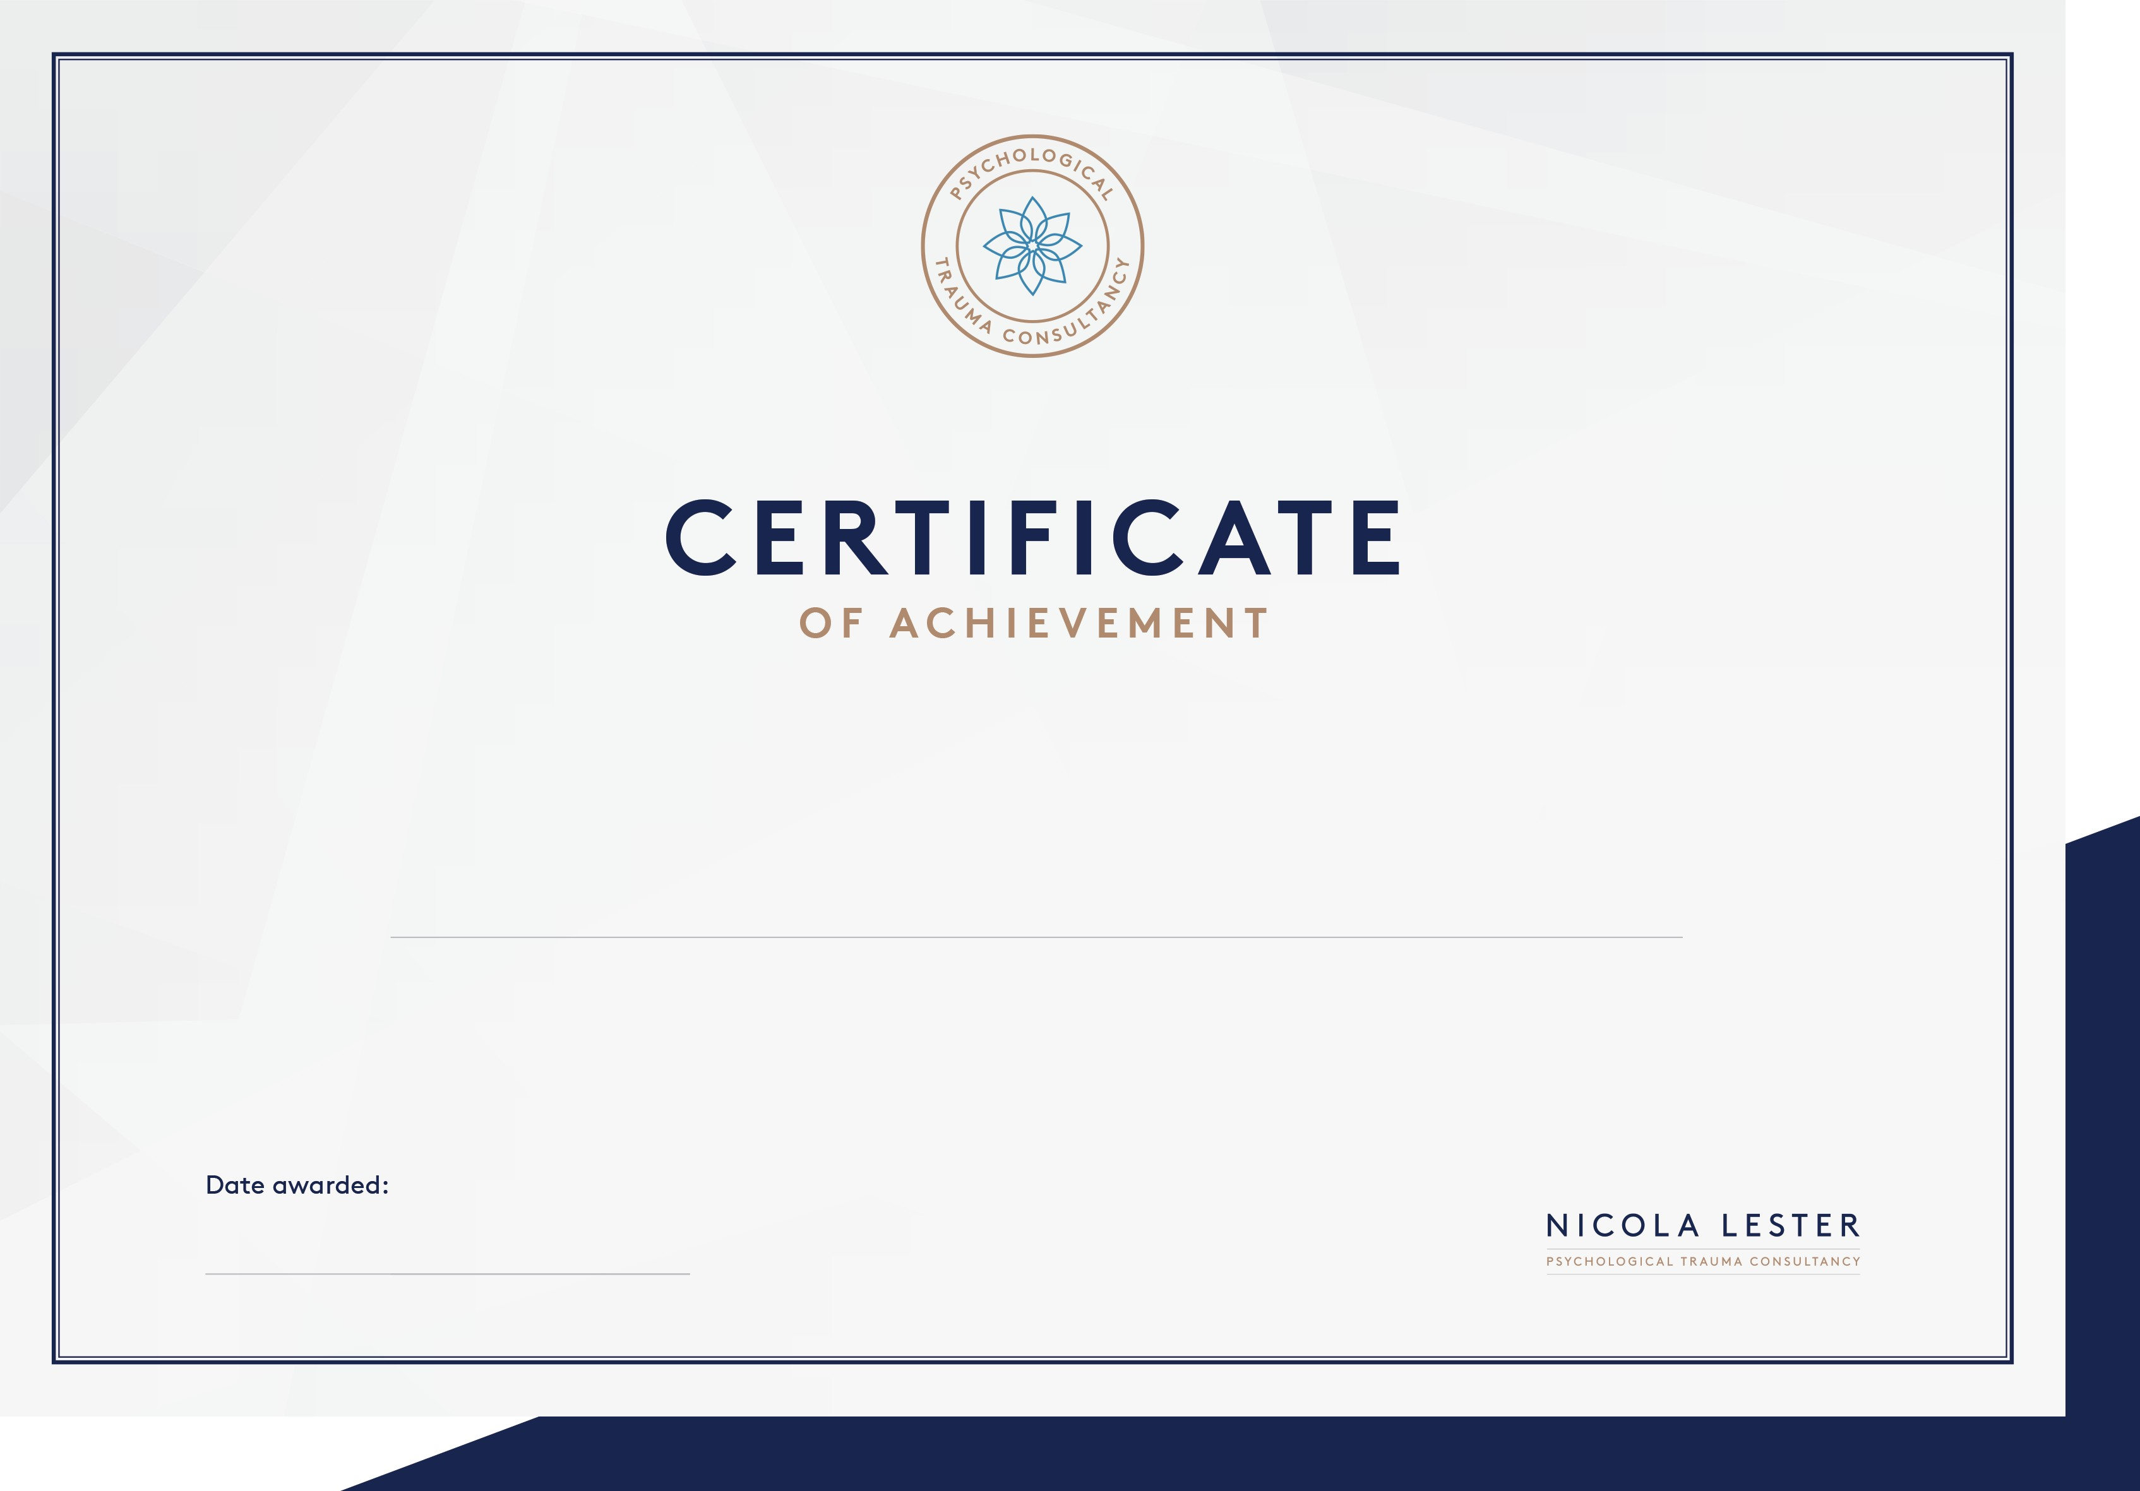

This certificate is awarded to

This certificate has been awarded for participation in a ‘Introduction to Trauma’ Continuing Professional Development webinar

8th September, 2020

